
Company
Logotype

Cone Beam Computed Tomography- Report



Porur Dental X-rays & CBCT

Patient Name : Master. Dejo Willwish | Date of Report : 06.07.2024
Age/ Gender : 8 years/ Male | Region of Interest : CBCT Sectional Maxilla
Referring doctor: Dr. Balamurali Sai | Indication : Fractured tooth: 21
Clinical Notes: Nil
PATIENT INFORMATION

CBCT- Maxilla provided
CBCT – IMAGE DETAILS

RADIOGRAPHIC INTERPRETATION

- Presence of hyperdense crown structures in relation to 24, 25, 26, 27, 28 and implant screw in relation to 25.
- In relation to 17 presence of restorative material involving the crown and the disto buccal root canal is evident.
- In 16 presence of restorative material involving the crown and approximating the pulp is evident.
- In 23, partial loss of crown structure and hyperdense restorative material within the pulp canal upto the apical region is evident.
- In 26, partial loss of mesio- coronal structure involving the pulp is evident.
- The maxillary alveolar ridge is present with normal trabecular pattern.
- The surrounding bone in relation to the implant in 25 is present with normal trabecular pattern.

IMPLANT ASSESSMENT

 | 17 region | 23 region
Sub-Crestal | 13.98 | 7.43
Mid- Crestal | 14.12 | 7.09
Distance between the alveolar ridge and Floor of the Nasal cavity (in mm) | 6.02 | 21.81

RADIOGRAPHIC IMPRESSION

- Fractured crown in root canal treated tooth : 23
- Partial/ Incomplete root canal treatment in relation to 17.
- Restored: 16
- Implant in relation to 25
- Crown in relation to 24, 25, 26, 27, 28

Kindly correlate with clinical findings


IMAGES FOR REFERENCE

Reconstructed Panoramic view
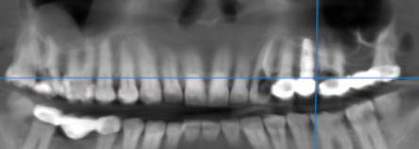

3-DIMENSIONAL VIEW

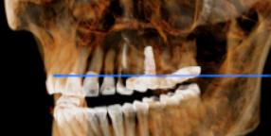

CROSS SECTIONAL VIEW

16 region | 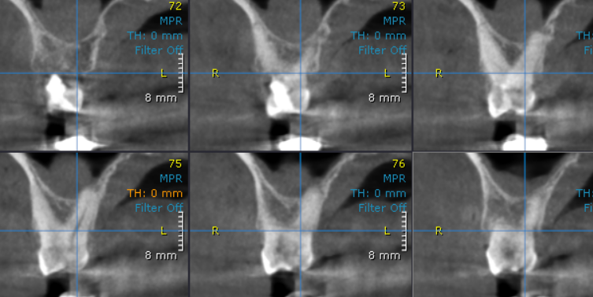
17 region | 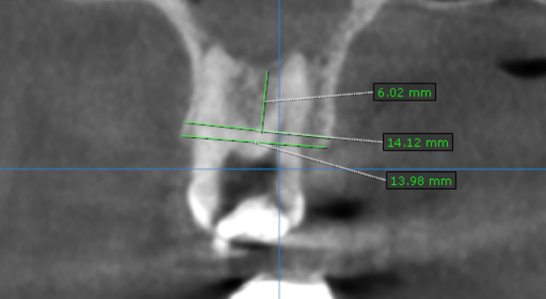
23 region | 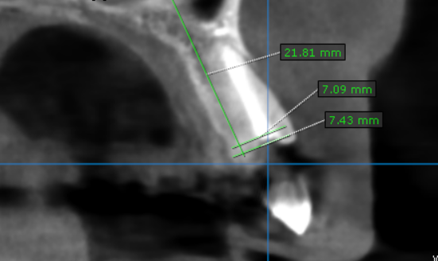
26 region | 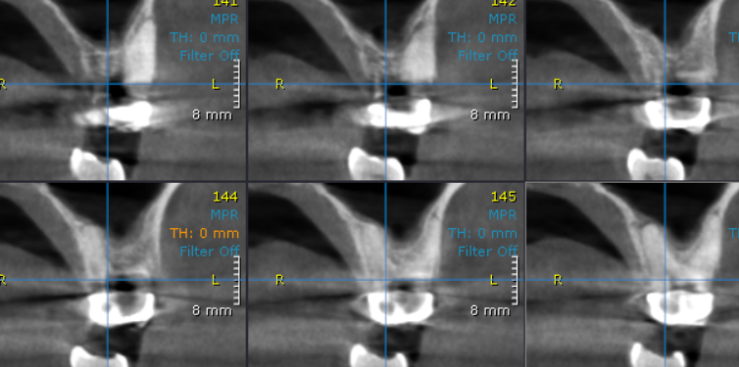

**** End of report ****

